Robotic Systems

CW2: Experiment 1

Preliminary results and work plan proposal

# Group: “Juantxotl”

Carolina Avila

Yusseff Dominguez

Rodrigo Moreno

Esteban Ochoa

6th April 2019

# Research topic:

How to maximize grid coverage while having an acceptable mapping accuracy.

# First experiment:

### 2.1. Materials and methods:

**Materials:**

- Baseline code with random movement and speed control.

- Marking of visited cells ‘V’ added to the mapping function.

- Only Line Sensors and Proximity sensor enabled. RF sensor not considered necessary at this stage.

- Only one proximity sensor at the front of the robot.

- Video recording of every experiment to track path followed by the robot.

**Goal of the experiment:**

Quantify the percentage of covered cells and mapping accuracy for a simple random behaviour.

1. **Coverage**: The percentage of explored cells is extracted from the printed map. This information is verified using video recordings of the experiment and visually tracking the path followed by the robot within the map. For this first experiment, visual tracking was done manually just observing the videos; but time-permitting, we would like to implement an automatic tracking of the robot’s path throughout the whole experiment using a computer vision tracking algorithm.
2. **Mapping accuracy**: This is proportional to the similarity between the printed map and the ground truth map. Comparing both maps we have quantified the percentage of cells identified correctly from the total of explored cells. We have also distinguished between ‘feature’ cells and ‘free’ cells. For future experiments we want to come up with a scoring method which provides a final score from quantification of the similarity between both maps.

**Generation of ground truth map:**

* The image file provided with the map of the experiment was processed in Matlab to generate another image of the map with the grid on top (Figure 1). The grid has the same size defined in the robot’s mapping function (25 x 25 = 625 cells).
* From the above grid image, a ground truth map file was manually generated in Excel. This file has the same format as the map printed from EEPROM memory by the robot, using specific characters to identify content of different cells (Figure 2). Obstacles were marked as ‘O’, lines as ‘L’, RFID tags as ‘R’ and free visited cells as ‘V’.

**Performed experiments:**

* Five different trials.
* Total duration per trial limited to 20 sec. Since obstacle avoidance behaviour was very basic and the likelihood of hitting obstacles was quite high, it was decided to reduce the duration of the experiment.
* The maps printed by the robot were saved as txt files and later processed in Excel for results extraction.

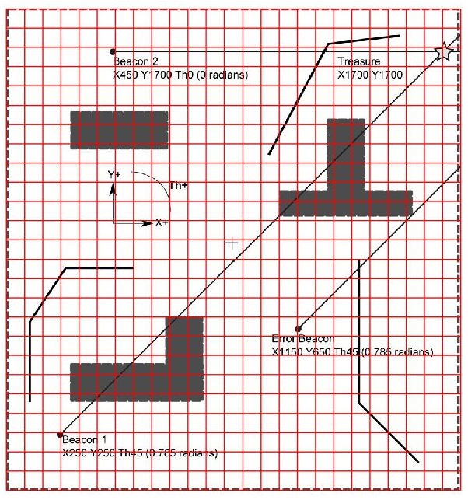

Figure 1. Processed image of the ground truth map with the grid.



Figure 2. Ground truth file created in excel from grid image of the map.

### 2.2. Results:

For each trial, the printed map was processed and compared to the ground truth map file. Figure 3 shows the results for one of these trials. Printed maps were verified against the video recordings. Visual analysis of the videos shows a high correspondence between the path followed by the robot and the printed map. However, it is difficult to quantify the level of error in the explored cells just with visual inspection a more accurate method to verify the covered cells is desirable (e.g. use CV for video-tracking with a superimposed grid).

Different metrics were obtained manually for each experiment map (we would like to automatize the process of cell identification, feature counting and comparison to ground truth with a program for future experiments). Results for each individual test as well as the average values are summarized in Table 1.

 

Figure 3. Left: Ground truth file. Right: Map created by the robot in one of the experiment trials.

|  |  |  |  |  |  |  |
| --- | --- | --- | --- | --- | --- | --- |
| **Metrics** | **Test 1** | **Test 2** | **Test 3** | **Test 4** | **Test 5** | **Average** |
| Absolute number of explored cells | 37 | 46 | 37 | 37 | 51 | **41.6** |
| % Explored cells | 5.92 | 7.36 | 5.92 | 5.92 | 8.16 | **6.66 %** |
| Absolute number of cells marked as feature (Obstacle or Line) | 17 | 11 | 16 | 17 | 31 | **18.4** |
| Absolute number of ‘feature’ cells correctly identified | 9 | 1 | 4 | 13 | 8 | **7** |
| % of ‘feature’ cells correctly identified | 52.94 | 9.09 | 25.00 | 76.47 | 25.81 | **38.04%** |
| % Features detected during experiment | 8.04 | 0.89 | 3.57 | 11.61 | 7.14 | **6.25%** |
| Absolute number of cells marked as free ‘V’ | 20 | 26 | 30 | 20 | 19 | **23** |
| Absolute number of free cells correctly identified | 20 | 22 | 24 | 20 | 15 | **20.2** |
| % of free cells correctly identified | 100 | 84.62 | 80 | 100 | 78.95 | **88.71%** |
| % Explored cells correctly mapped | 78.38 | 50.00 | 75.68 | 89.19 | 45.10 | **67.67%** |

Table 1. Summary of results. Metrics quantifying coverage and mapping accuracy.

For an experiment duration of 20 seconds, average percentage of explored cells (with regard to the total number of cells in the map) was 6.66% and feature-mapping was just 6.25% of the total number of obstacle/line feature cells.

From the total of explored cells, 67.67% were correctly mapped either as ‘feature’ or ‘free’. Only 38% of the cells marked as features were correctly mapped.

**Further observations:**

* The robot hit an obstacle in 3 out of the 5 tests.
* The robot went out of the map boundaries in one of the tests.

# Future work:

### Stage 1: Immediate improvements:

* Implement behaviour to turn and head inwards when robot reaches map boundary cells.
* Improve obstacle avoidance behaviour:
  + Use 3 IR sensors
  + Improve sensor calibration: calibrate for different reflectance levels and use average value for final calibrated reading.

### Stage 2: Implement and test exploration algorithm:

1. Investigate possible exploration strategies.
2. Implement selected exploration algorithm within the movement behaviour of the robot.
3. Test accuracy of the exploration algorithm on a grid map with no obstacles. The goal here is to evaluate the effect of kinematic accuracy on the programmed motion pattern during exploration. The deviation from the originally planned trajectory will be directly measured over the physical map (e.g. planned trajectory could be drawn over the map and deviation points marked during the experiment).
4. Test implemented exploration algorithm on a real-scenario map with obstacles: evaluate level of improvement in map coverage and mapping accuracy with regard to baseline experiment.

### Stage 3: Improve kinematics:

1. Implement sensor fusion method to combine encoders, gyroscope and magnetometer readings to improve heading estimation.
2. Test kinematics improvement regardless of the exploration algorithm: over a known planned trajectory, measure the deviation error before and after implementing sensor fusion solution. As in point 3 above, this planned path could be drawn over the map and deviations marked on top and measured.
3. Test effect of kinematics improvement on the exploration algorithm: First with no obstacles (same as point 3 above) and then with obstacles.

# Implementation expectations:

Minimum:

* 1. **Complete Stages 1 and 2**.
  2. Manual verification of explored cells using direct visual check on videos.
  3. Program for automatic processing of map files for metrics extraction.

Medium:

1. **Complete Stages 1 to 3**.
2. Manual verification of explored cells using direct visual check on videos.
3. Program for automatic processing of map files for metrics extraction.

Maximum:

1. Complete Stages 1 to 3.
2. **Program CV tracking algorithm for a more accurate reconstruction of the actual robot’s path** throughout the experiment and improve verification of the explored cells.
3. Program for automatic processing of map files for metrics extraction.